Project 8: Modeling Rocket Flight

Part 1: Relate Zeros to the Factored Form of Quadratic Equations
- What is the factored form of the quadratic equation represented by the graph? Explain how you found your answer.
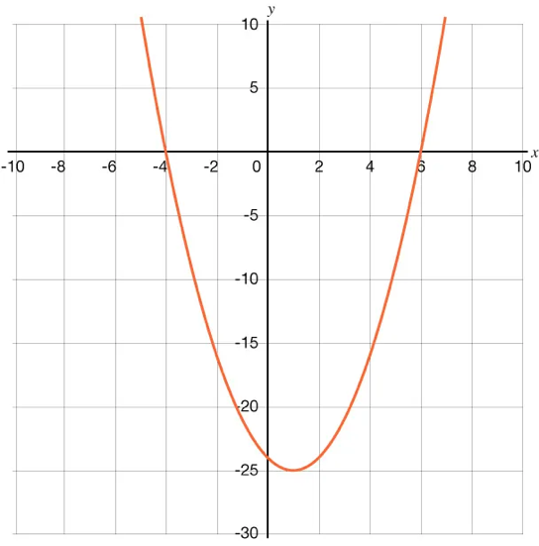
- How many times does the graph of the equation $\left(x-5\right)\left(x-5\right)=0$ intersect with the $x-$axis? Be prepared to show your reasoning.
- The equation $x^{2}-8x+20=0$ is shown in the graph. How many solutions does the equation have? Be prepared to show your reasoning.
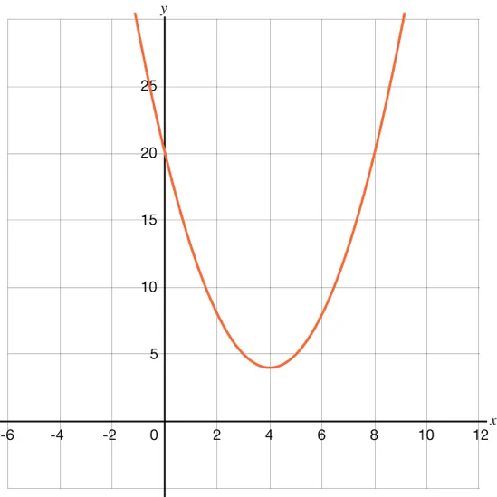

Part 2: Convert between Factored Form and Standard Form
You have learned strategies for writing a quadratic expression in its factored form and standard form. In each round of this activity, you and your partner will be given equivalent quadratic expressions in different forms.
The goal of each round is to write the quadratic expression as it has been given to your partner. If your expression is in factored form, write it in standard form. If your expression is in standard form, write it in factored form. At the end of each round, compare the expressions with your partner without revealing the expressions for future rounds.
If, in any round, you need help, you may ask your partner to explain the next step without revealing the solution.
Proceed from rounds 1 to 6 while discussing your thinking if there is any disagreement.
Round | Equation
1
2
3
4
5
6

Part 3: Model a Rocket Flight
Alejandra lights the fuse on a small toy rocket. The fuse burns down and, after 1 second, the rocket launches into the air. The rocket lands back on the ground after 6 seconds.
After 5 seconds from when Alejandra lit the fuse, the height of the rocket was 8 meters.
- What is the quadratic equation in standard form that models the flight of the rocket? (Hint: Think of the problem as a quadratic function in which you know the zeros and a point through which the function passes.)
- Use the equation you found in the previous question to find the height of the rocket, in meters, 3 seconds after Alejandra lit the fuse.

